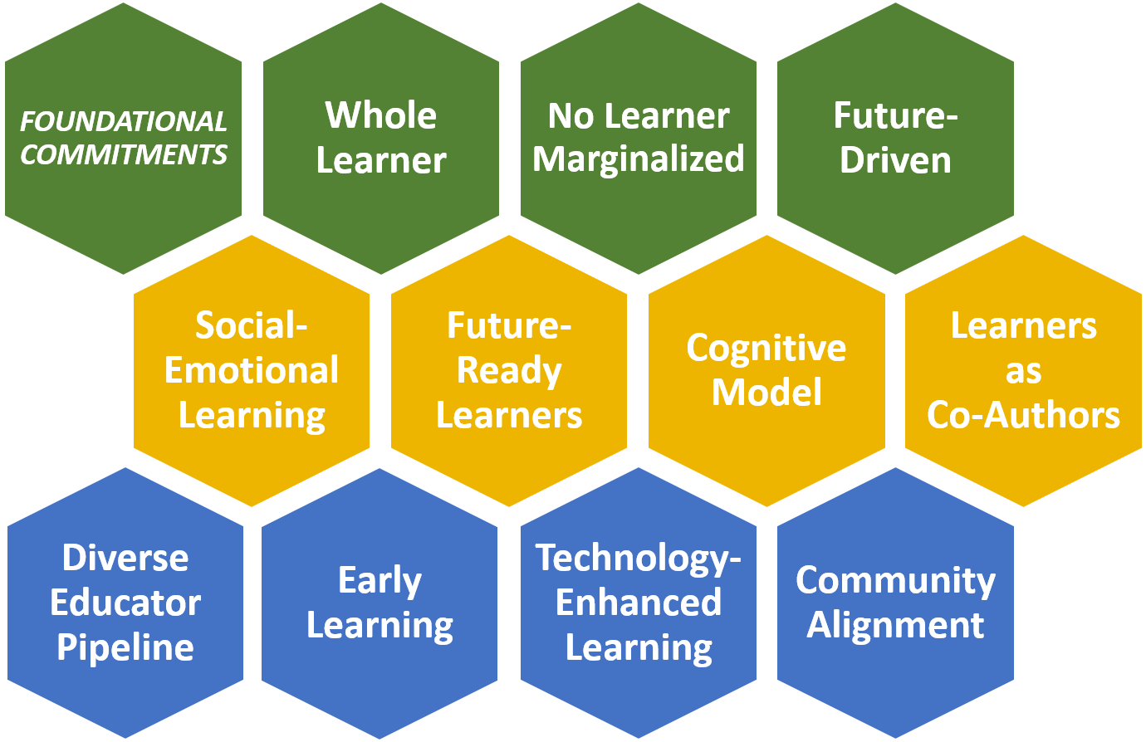
Priorities Self-Assessment (Tool II)

This Self-Assessment can be used to reflect on how well your current plans align with the AASA Learning Recovery & Redesign Priorities. As you maximize the short-term impact of federal ESSER dollars, how are you also advancing any of the eleven components of the
AASA Learning 2025 framework?

The focus here is on ESSER funds, but you should reflect on how you can leverage all available resources.

Which Learning 2025 component are you focusing on for this self-assessment?

Pre-pandemic, to what extent was this Learning 2025 component an emphasis for your district?
 | Minimally |  | Somewhat |  | Moderately |  | Significantly
Why did you select that answer? What would you point to in order to justify your answer?

At this point, to what extent is it an emphasis in your current recovery and redesign plan?
 | Minimally |  | Somewhat |  | Moderately |  | Significantly
Describe specific ways your current plan (especially your use of ESSER funds) advances this component:

Moving forward, to what extent do you want it to be a point of emphasis for your district?
 | Minimally |  | Somewhat |  | Moderately |  | Significantly
Why did you select that answer? What adjustments are you considering or do you want to explore?

What challenges will you face as you work to strengthen policies, processes, and a culture aligned with this Learning 2025 component? What are some solutions you might pursue?
NOTE: Specifically consider challenges facing your most marginalized student populations.

Likely Challenges | Potential Solutions
Specific challenges facing marginalized students | Potential Solutions

How can you use ESSER funds to advance this component? What seeds can you plant now?
For concrete recommendations on how to advance this Learning 2025 component, see the accompanying row of the table found in the Learning Recovery & Redesign Priorities document.
(Clicking the links below will take you to the relevant section.)

Culture | Social-Emotional, Cognitive Growth | Learning Accelerators
Whole Learner  No Learner Marginalized  Future-Driven | Social-Emotional Learning  Future-Ready Learners  Cognitive Growth  Learners as Co-Authors | Diverse Educator Pipeline  Early Learning  Technology-Enhanced Learning  Community Alignment
Which resources (or recommendations within them) seem most useful to your reflection and revision?

What will you do differently now?
After reviewing your plans, your responses to this Self-Assessment, and the recommended resources, what changes will you make to better advance this component? Use the table below to identify your team’s next steps, responsible team member(s), deadlines, and resources needed to succeed.

Action Item | Owner | Deadline | Resources Needed
More AASA Learning Recovery & Redesign Guidance resources are forthcoming and can always be found here.
Please click here to provide your feedback and/or suggestions for what else would be most helpful.

